|  |  |  |
| --- | --- | --- |
| Roll No. |  | XXXXXXXXXX |
| Student Name |  | XXXXXXXXXX |
| Class |  | III B. Tech II SEM-CSE |
| Section |  | A/B/C/D |
| Academic Year |  | 2020-21 |
| Course Name |  | **ROBOTIC PROCESS AUTOMATION DESIGN & DEVELOPMENT** |

**Task-1 :**

**Write the Task description**

**Step 1:** Create a **Blank project** by choosing the Process and mention details such as name, location, and description of the Project. Refer below.

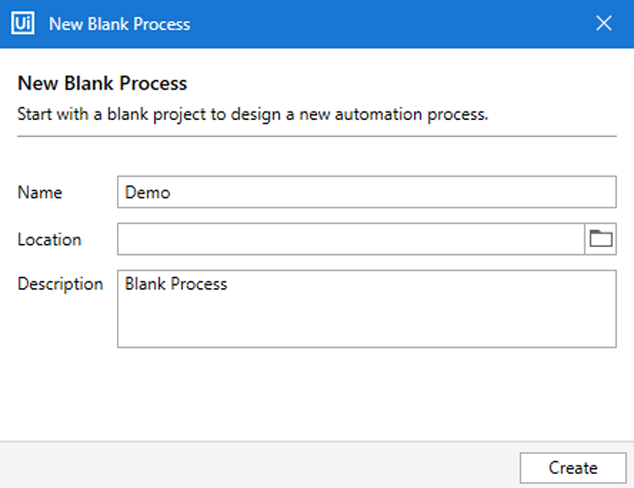

**Step 2:** Drag and drop a **sequence** in the main panel and then drag and drop an **Input Dialog.**

**Step 3:**  In the **title section of Input Dialog** mention “*Mention your name*” and in the label section mention “*What is your name?*“.

**Step 4:** In the **properties section** of the Input Dialog activity go to the output section and press on **CTRL + K** to create an output variable as *sample*.

**Step 5:** Next, drag and drop an **Assign activity** and in the **To section of Assign activity** create a variable as *output*. After that, in the value section mention, the  expression New String(sample.ToCharArray.Reverse.ToArray)

**Step 6:** Now, make sure that the data types of the variable created is **String**.

**Step 7:** Finally **add a message box**, to display the output and mention the output variable as *output [created in step 2].*

**Step 8:** Execute the project by clicking on the run button. Your final workflow should be as below:

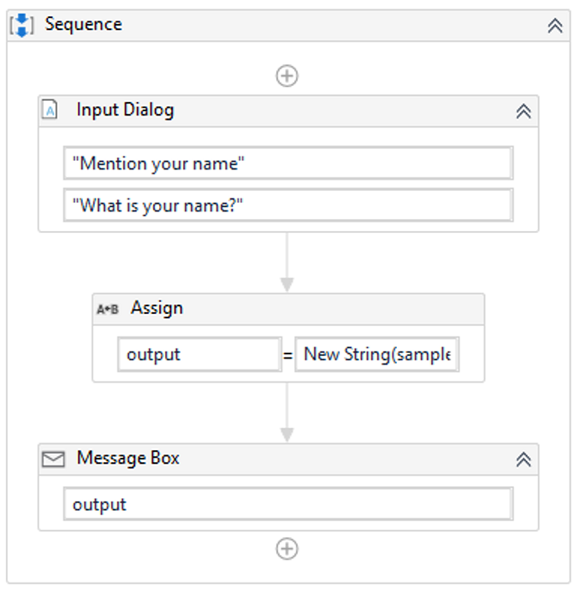

**Output:**

